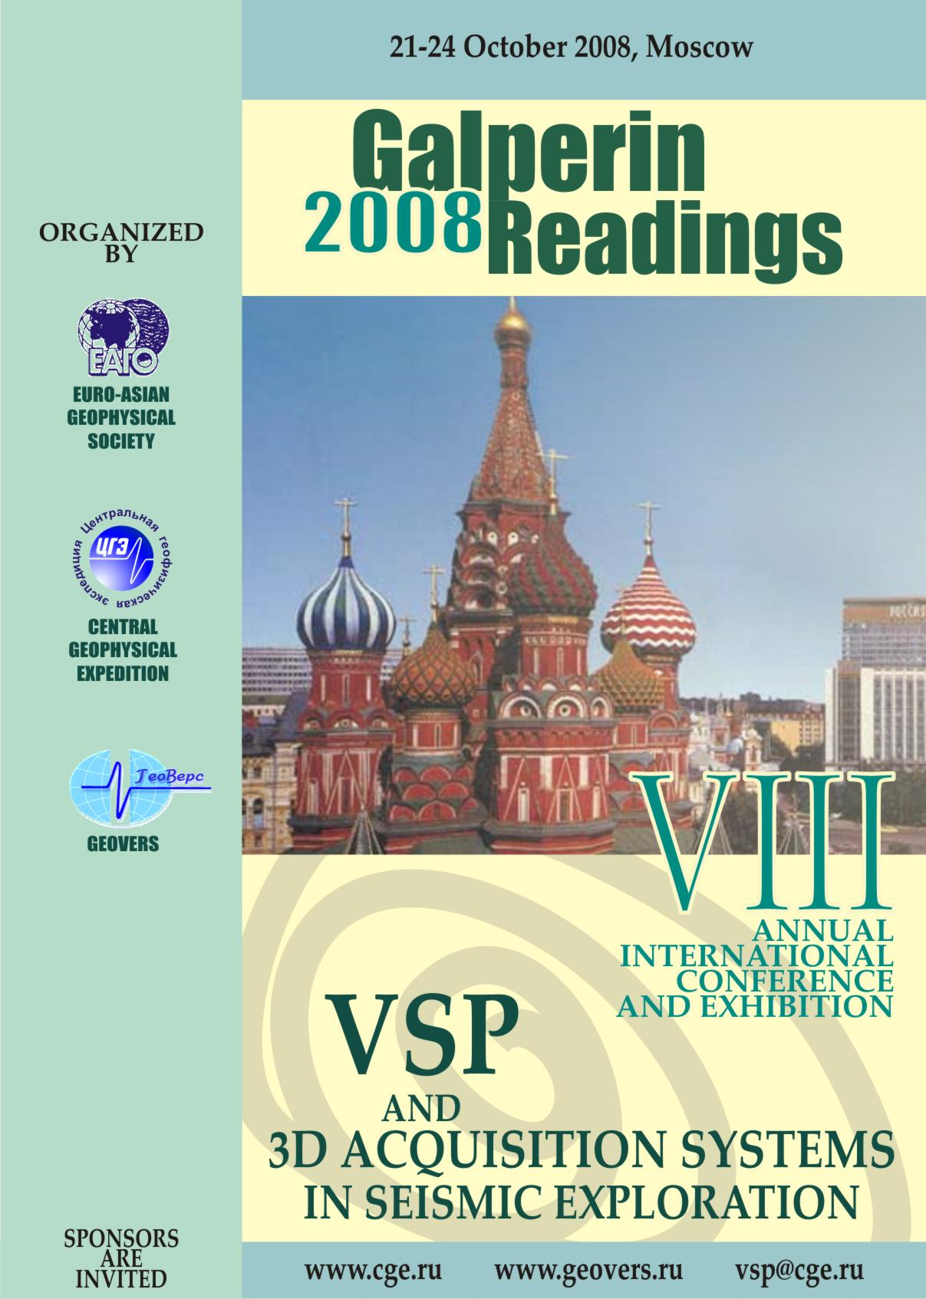

First Announcement

VIIIth Annual International Conference and Exhibition
VSP and 3D Acquisition Systems in Seismic Exploration

Galperin Readings is a specialized annual forum on vertical seismic profiling (VSP), inheriting traditions founded by E. I. Galperin, the inventor of the VSP method.

The main subject of the forum is the integration of surface and borehole seismic surveys in order to increase efficiency of seismic exploration.

Since 2006, Galperin Readings Conference is held under sponsorship and informational support by the European Association of Geoscientists and Engineers (EAGE), Euro-Asian Geophysical Society (EAGO), PetroAlliance Service Company and other interested geophysical and oil companies.

Conference Purpose is to exchange experience and to demonstrate new capabilities of the VSP method in combination with surface seismic in order to aid providing solutions to complex geological tasks in the search for and development of oil and gas reservoirs.

Exhibition Purpose is to show latest achievements in the development of acquisition tools, devices and other auxiliary facilities for VSP surveys.

Oil and gas companies, geological and geophysical companies as well as research centers, universities and other interested organizations are invited to participate in the Conference and Exhibition.

Venue
The Conference and Exhibition will be held at the Central Geophysical Expedition (CGE), one of the leading geophysical services provider in Russia.

Address: 38 Narodnogo Opolcheniya St., Bldg 3, 123298 Moscow, Russia.
How to reach: CGE is located within walking distance (5-10 min.) from subway station «Oktyabrskoye pole».
(refer to the map on the last page or visit the web-site: http://www.cge.ru/ Pages/Map/road.html)

Schedule
October 20-21, 2008 – Registration.
October 21, 2008 – Excursion to The Golden Ring of Russia.
October 22-23, 2008 – Conference and Exhibition.
October 24, 2008 – Commercial presentations of software tools and technologies.
Participation
To participate, please fill out an Application Form (Appendix 1) and deliver it by mail, e-mail, fax or on-line to the Organizing Committee. Please, submit
- Application for Presentations – by September 15, 2008
- Application for Participation in Exhibition – by October 1, 2008
- Application for commercial presentations – by October 10, 2008
- Application for Conference and Exhibition Attendance – by October 15.
▪ The Technical Program will consist of oral and poster presentations. Submitted papers should reflect the latest achievements in borehole seismic acquisition techniques and software development for use in integrated processing and interpretation of acquired VSP and surface seismic data.
▪ Oral Presentations will be held in the conference hall of CGE. Up-to-date technical devices (digital and overhead projectors) will be available. The reports should be attended with the slideshow in Russian and English languages (see Appendix 3 for an example) because of the simultaneous translation complexity. The questions and answers will be attended with a simultaneous translation.
▪ Poster Presentations will be on display in a special area beside the Conference Hall. A 2.5 m x 1.5 m poster box will be provided for each poster presentation.
▪ Conference Materials
Extended Abstracts will be available by the beginning of the Conference both in paper and electronic (CD-ROM) versions.
Extended Abstracts must be submitted by e-mail to vsp@cge.ru, manukov@cge.ru and may contain up to 4 pages (including figures and literature references). Please, refer to the Text Format Requirements and use the suggested template (Appendix 2).
An Extended Abstract must also include title and short abstract (up to 200 words). The Russian version of the text is desirable but not necessary.

▪ Exhibition
Due to the limited space available for the Exhibition, the Organizing Committee recommends presenting small-sized exhibits reflecting the most modern developments or photographs of the exhibits. Exhibitors are expected to use their own facilities to deliver their exhibits.

▪ Commercial Presentations
Companies that wish to introduce their specialized software and technologies for integrated processing and interpretation of VSP, surface seismic and logging data must send in a completed Application Form (Appendix 1) to the Organizing Committee.
.
Registration Fees
Registration fee for participants and attendees is €300. The value of the registration fee covers organization expenses, publishing of Extended Abstracts, coffee served at breaks between sessions and a Social Program.
Cost of rent in the Exhibition area is €80 per 1 m².
Commercial presentation fee is €220 per 1 hour.
VAT is not included.
Payment may be made by bank transfer to Geovers Ltd.:

Beneficiary customer: | GEOVERS Ltd.  Address: 15 building 8, Nagornaya Street,  117186, Moscow City, Russia
Beneficiary bank name and address: | Name: SBERBANK, Moscow (Head office-all Russian offices and branches)  Address: Moscow, Russia  SWIFT: SABR RU MM  Krasnopresnenskoye Branch 1569
Beneficiary account in Beneficiary bank | 40702978438170209491
Correspondent bank of Beneficiary bank | Name: Deutsche Bank AG, Frankfurt am Main, Germany  Address: Frankfurt am Main, Germany  SWIFT: DEUTDEFF  CORRESPONDENT ACCOUNT: 10094987261000

Payments must be certified by fax at: +7 (499) 192-8135 or by e-mail: vsp@cge.ru. Please indicate clearly on all cheques and bank transfers your name and payment title as “Registration fee, Galperin Readings – 2007”.
Registration fees may also be paid onsite in cash during registration.

Sponsorship
The Conference and Exhibition are financially reliant entirely on registration fees, rent for exhibition space and commercial presentations.
As these resources do not cover all necessary expenses, the Organizing Committee invites participating companies to sponsor the Conference and Exhibition.
Your sponsorship (expected minimal contribution is €2000) will be mentioned in the Conference materials. Sponsoring the Conference entitles you to have an advertisement of A5 size published in the Extended Abstracts book and to have an advertising presentation time of your products secured for free. Moreover, logos of sponsoring companies will be placed on the Extended Abstracts book cover. The Sponsor may also provide an advertisement, booklet or any other information materials which will be handed out to each delegate of the Conference.

Accommodation
Booking of rooms is not provided by the Organizing Committee but can be easily made via the Internet: www.hotelmos.ru. You may also contact LeVas company (phone/fax +7 (499) 943-5929, е-mail: levas@mail.cge.ru) for accommodation reservation.

Social Events
Moscow is a beautiful modern capital city of Russia with a long and rich history. A Social Program will be prepared to make participation in and attendance of the Conference not only a scientific and business trip, but also an interesting and exciting journey.
In addition, Technical Program will be crowned by a Farewell Dinner where Conference participants and attendees will be able to discuss the Forum results in an informal setting.

Information on the preparation of the Conference and Exhibition will be sent to you and placed on the web site www.geovers.ru.

Organizing Committee:
Phone: +7 (499) 192-6539, fax: +7 (499) 192-8088
Phone/ Fax: +7 (499) 192-8135
www.geovers.ru

Committee Chaiman: Dr. Alexander Tabakov, e-mail: vsp@cge.ru.
Executive Secretary: Victor Manukov, e-mail: manukov@cge.ru.

Appendix 1

October 21-24, Moscow, Central Geophysical Expedition |  |  |  |  |  |  |  |  |  |  |  |  |  | Galperin Readings – 2008
APPLICATION FORM
1 | Surname_______________________________________________________________________________
Name________________________________________ |  |  |  |  |  |  |  |  |  |  | Middle Name_______________________________
Academic Degree ___________________________________________________________________________
Company/Institute___________________________________________________________________________
CEO of Company/Institute ____________________________________________________________________
Postal Address______________________________________________________________________________
Zip Code________________ |  |  |  |  | City___________________ |  |  |  |  |  |  | Country______________________________
Phone__________________ |  |  |  |  | Fax___________________ |  |  |  |  |  |  | E-mail_______________________________
2 | □ Presentation |  | □ Exhibit |  |  |  |  | □ Commercial Presentation |  |  |  |  |  |  |  | □ Attendee*
*Note: Attendee is entitled to attend all Conference sessions, including the Technical Program, Exhibition, and Commercial Presentations, as well as the Farewell Dinner and other events of the Social Program.
3 | Presentation**:
Paper Title____________________________________________________________________________
___________________________________________________________________________________________
___________________________________________________________________________________________
Co-Authors: |  | Name___________________________ |  |  |  |  |  |  |  | Company/Institute ____________________________
 |  | Name ___________________________ |  |  |  |  |  |  |  | Company/Institute ____________________________
 |  | Name ___________________________ |  |  |  |  |  |  |  | Company/Institute ____________________________
 |  | Name ___________________________ |  |  |  |  |  |  |  | Company/Institute ____________________________
Desired Type of Presentation: |  |  |  |  |  |  | □ Oral |  |  |  |  |  | □ Poster
Required Devices: |  |  |  | □ PC |  |  |  |  | □ Digital Projector |  |  |  |  |  | □ Overhead Projector
**Note: an oral presentation will be allocated 15-20 minutes including discussion; a poster presentation may be displayed for half a day. The Organizing Committee reserves the right to change the final type of presentation.
4 | Exhibit:
Name of Exhibit_____________________________________________________________________________
___________________________________________________________________________________________
___________________________________________________________________________________________
Size of Exhibit________________ |  |  |  |  |  | Required Exhibit Floor Space: ________________________________
Form of Presentation: |  |  |  |  |  |  | □ A Photograph |  |  |  |  |  | □ Exhibit
5 | Commercial Presentation (submission deadline – October 10, 2008):
Presentation Title ___________________________________________________________________________
___________________________________________________________________________________________
___________________________________________________________________________________________
Presentation Length__________________________________________________________________________
Note: each delegate must submit a separate individual Application Form

Appendix 2

Text Formatting Requirements
Texts of the abstracts must be edited and formatted in the following way: Word 7 compatible file, font – Times New Roman, font size – 14, line spacing – single. Margins – 2.5 cm at all margins. Paragraph first line indentation – 1 cm, alignment by width.
The abstract title should be typed centrally adjusted in capital bold letters, no hyphenation. The title should be preceded by a code indicating the desired presentation form (О – oral, Р – poster), and the session number of session in which the abstract is to be included (1 – New Developments and Software, 2 – Processing and Interpretation Techniques, 3 – VSP and Integrated Seismic Surveys: Case Studies, 4 – Equipment and Data Acquisition). Please leave a blank line beneath the title. The line below the blank line is for he names of the authors. Organizations represented by the authors must be indicated on the following line in italic font. If the authors are from various companies, their names should differ with asterisks (*). Please, separate the abstract text with two blank lines from the headings. (see Template below).
Figures (GIF, TIF, JPG files) and tables (Word, Excel files) must be provided as separate files. Authors are strongly requested not to insert figures into the same file as the main text of the abstract. Maximum acceptable size of the figure is А5.
The paper version of the Extended Abstracts will be printed in black and white. Please submit both black-and-white and color versions of all figures for electronic publication.
Literature references should be formatted according to general convention

.
O1 ABOUT PRINCIPLES AND ACTUALITY OF COMBINING
SURFACE AND DOWNHOLE ACQUISITION
GEOMETRIES (3D+VSP, 2D+VSP)

A.A. Tabakov*, K.V. Baranov*, V.L. Eliseev*,
A.V. Reshetnikov**, A.V. Kopchikov**
(* CGE, Moscow, ** Geovers, Ltd., Moscow)

Summary. …

Text of the abstract

Appendix 3

Presentation Requirements
Presentation must include two-lingual content (Russian and English languages). To enhance visual expression is recommended to highlight text of different languages by color or reduce font size of translated text. Labels on figures: scale captions, dimensions, etc could be in English only.

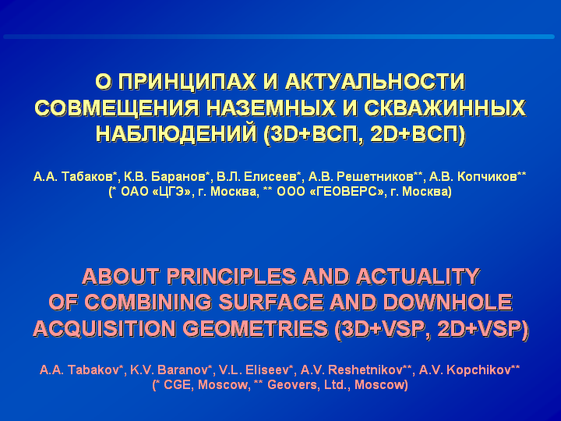 | 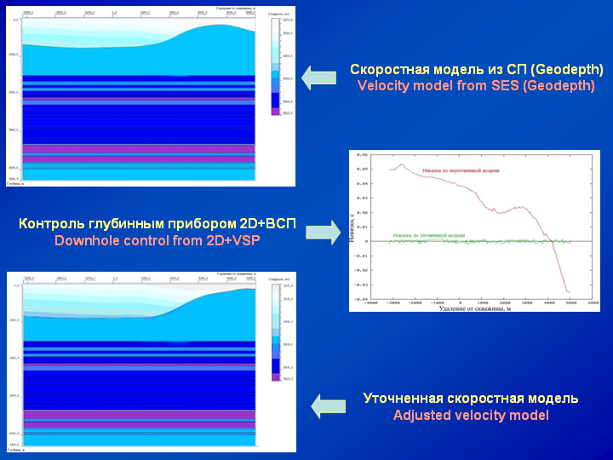
Presentation title and authors list | Slide including figures

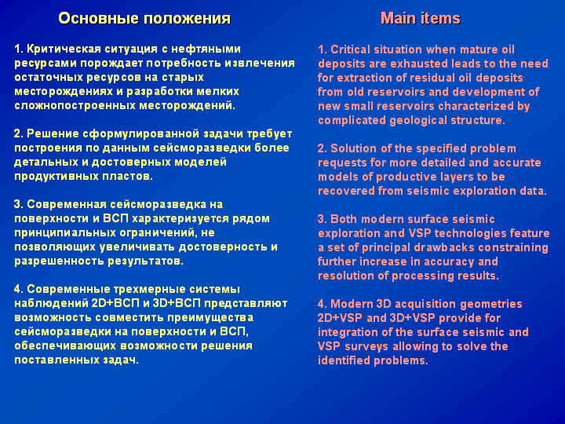 | 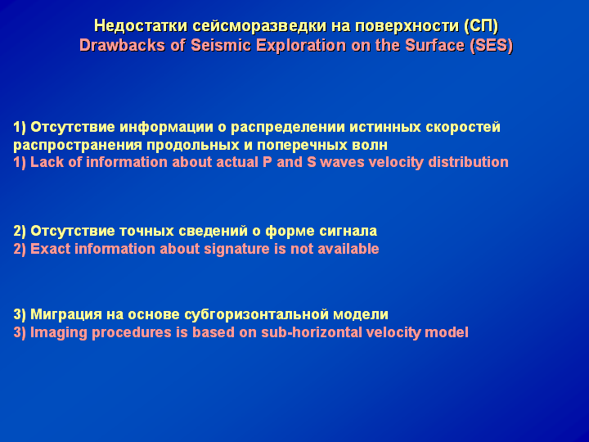
Vertical separation by language | Interlinear translation

Map

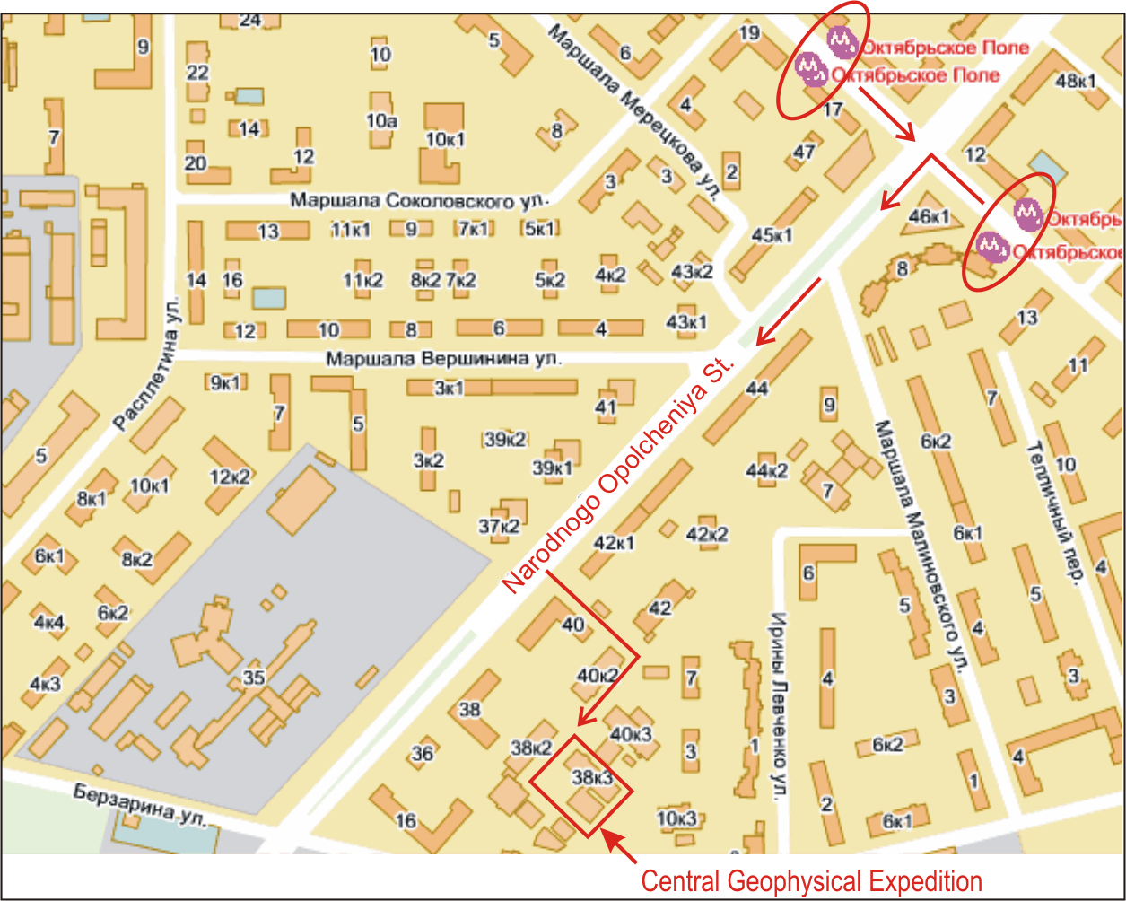

Address: 38-3, Narodnogo Opolcheniya St., 123298 Moscow, Russia.

How to reach: CGE is located within a walking distance (5-10 min.) from subway station «Oktyabrskoye Pole».

